[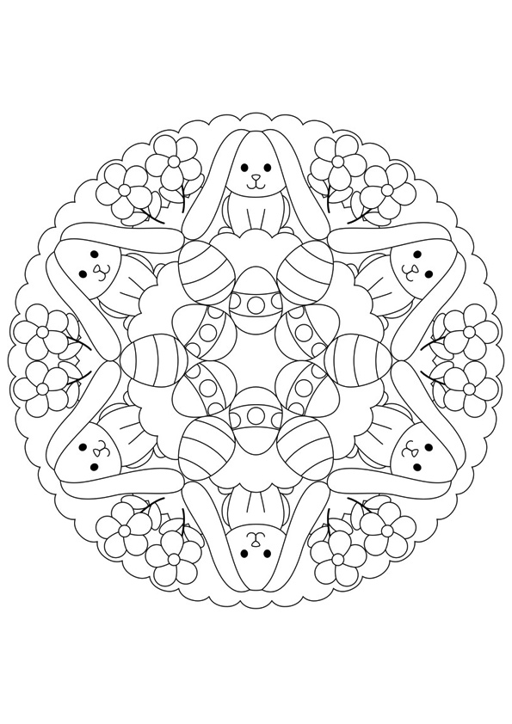](http://www.momjunction.com/print-coloring-image?print=2014/09/The-hello-kitty&pageid=90722)

